A look at 100 boys that join Scouting  12 will receive their first time religious contact  5 will earn their religious emblem  2 will enter the clergy  18 will develop hobbies that will last a lifetime  8 will enter a career based on Merit Badges work  17 will become Scout volunteers  1 will use Scouting skills to save the life of another person  1 will use Scouting skills to save his own life  2 will attain the rank of EAGLE  Were you aware that Boy Scout Alumni include:  63% of Air Force Academy graduates  68% of West Point graduates  70% of Annapolis graduates  72% of Rhodes Scholars  85% of FBI agents  65% of college graduates  65% of US Congress  85% of airline pilots  85% of student council presidents  89% of senior class presidents  80% of junior class presidents  71% of football captains  65% of basketball captains  88% of school newspaper editors  77% of editors of school annuals  75% of business managers of school publications  Of the 294 pilots and scientists selected as astronauts since 1959, more than 180 were Scouts or have been active in Scouting: 37 Eagle Scouts, (including Neil Armstrong-first man on the moon), 25 Life Scouts, 13 Star Scouts, 27 First Class Scouts, 16 Second Class Scouts, 13 Tenderfoot Scouts, three Explorers, 29 Cub Scouts, 16 Webelos Scouts, and eight with unknown ranks.  Of the 12 men to physically walk on the moon’s surface, 11 were involved in Scouting.  Sources: www.scouting.org and www.usscouts.org |  | 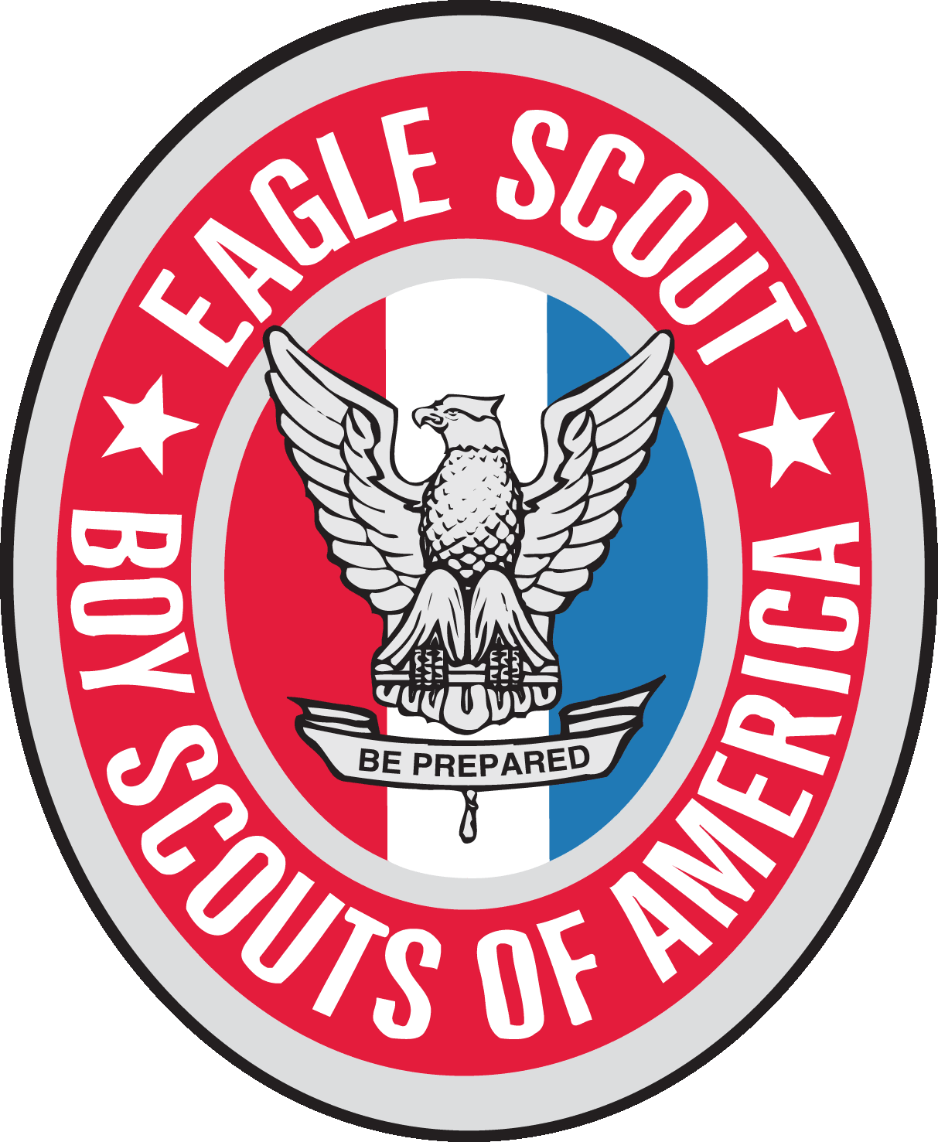  BOY SCOUT TROOP 8  CHEVY CHASE, MD  WELCOMES FRIENDS TO THE  EAGLE COURT OF HONOR  For  Peter Hutt-Sierra  Kai Jepson  William Richardson  11:00 am – 1:00 pm  May 31, 2015  Woman’s Club of Chevy Chase (WCCC)

Peter Hutt-Sierra’s, Kai Jepson’s,  & Will Richardson’s  Eagle Court of Honor  Welcome Ian Shonat  Senior Patrol Leader  Reid Flumbaum  Assistant Senior Patrol Leader  Presentation of Colors Troop 8 Scouts  Invocation Anne Marie Reidy-Borenstein  Troop 8 Chaplain  Introduction of Robin M. Richardson  Special Guests Committee Chair, Troop 8  Call to Order Kent Sneed  District Director  Potomac District  National Capital Area Council  Spirit of Scouting Jake Mullin  Eagle Scout  Trail to Eagle Mark Olinger  Eagle Scout  Eagle Scout Byron Lord  Service Projects Eagle Advisor  Potomac District  National Capital Area Council  Trail to Eagle & Remarks Andy Mullin  Scoutmaster Emeritus, Troop 8 |  | Give Me A Scout  Give me a Scout that will be strong enough to  Know when he is weak and brave enough to  Face himself when he is afraid…  …who is proud and undaunted in honest defeat  …but humble and gentle in victory.  Give me a Scout whose heart is clear and whose  Goals are high…  …who will learn to master himself before  …He tries to master others  …who has learned to laugh but has forgotten  …How to weep  …a Scout who will look to the future yet never  …Forget the past  …who has enough sense of humor that he may  …Always be serious.  Give me a Scout with humility to learn that to know himself  Is the foundation stone of all knowledge  …who has not followed the paths of ease and comfort  But has solidly face the trials of challenge  …who has learned to stand up to the teeth of the  Storm and has learned to accept passion for those  Who fail  …who has knelt to give sympathy to those who cannot  Help themselves.  Give me a Scout who so stands before his fellow men that his  Scoutmaster dares to whisper, “I have not lived in vain.”  And when you find this Scout…  He bears the mark of an Eagle.  This poem is a variation of “A Father’s Prayer,” written by General Douglas MacArthur “during the early days of the desperate campaign in the Far East in World War II.”

Eagle Scout Mom's Poem  A fond mother watches her boy where he stands  Apart from his comrades tonight,  As they place on his camp-battered tunic a badge,  An Eagle, the emblem of right.  It seems just a few short months have passed  Since he joined with the youngster next door.  How proud he was then of his tenderfoot pin  As he told her the message it bore.  But the years have gone as he struggled along  To Iearn what the Scout Law's about;  He practiced them daily, the Oath and Law  Until now he's an Eagle Scout.  You may smile in your worldly old wisdom at this  And say "Why it's only a pin"  But I tell you no honors he'll gain as a man  will mean just as much to him.  The red, white and blue of the ribbon you see  Are the symbols of honor and truth.  He has learned how to value these fine attributes  In the glorious days of youth.  And the outflinging wings of the Eagle that rests  On the breast of this knight of today  Are the things that will lift him above petty deeds  And guide him along the right way.  Yes, it's only a pin, just a Eagle Scout badge,  But the heart that's beneath it beats true  And will throb to the last for the things which are good.  A lesson for me - and for you.  Author Unknown |  | Obligations of Mike Silverman  Eagle Scouts Kalman Salata  Assistant Scoutmasters, Troop 8  Eagle Scout Promise Jerry Taylor  Scoutmaster, Troop 8  Eagle Rank Presentation Jerry Taylor  Scoutmaster, Troop 8  Eagle Statues Presentation Diane Dandois  Cliff Balkam  Westlake Foundation  Parents’ Remarks Peter Hutt  Robin M. Richardson  Susan Buchanan  Eagle Scouts’ Reflections Peter Hutt-Sierra  Kai Jepson  Will Richardson  Eagle Scouts, Troop 8  Closing Ceremony Ian Shonat  Senior Patrol Leader  Reid Flumbaum  Assistant Senior Patrol Leader  Retire the Colors Troop 8 Color Guard  Please join us for the reception immediately  following the ceremony.
Troop 8 Eagle Honor Roll  03/20/2015 Richardson, William J  11/14/2014 Jepson, Kai E  10/17/2014 Hutt-Sierra, Peter B  06/21/2013 Borenstein, Edward G  06/21/2013 Matus, Andrew J  06/21/2013 FitzPatrick, James B  06/21/2013 Salsbury, Daniel S  04/19/2013 Radack, Matthew  03/15/2013 Stablow, Alec M  03/15/2013 Aguado, Carlos A  02/15/2013 Silverman, Eric  02/15/2013 Canavan, John T  01/11/2013 Hodge, Nathaniel S  12/14/2012 Mullin, Jacob A  09/21/2012 Suarez, Nicholas R  06/15/2012 Olinger, Mark N  04/20/2012 Salsbury, James C  01/21/2012 Lippincott, Jesse C  01/06/2012 Thompson, John M  10/15/2010 Webb, Harold T  10/15/2010 Spencer, Anton R  07/16/2010 Webb, Thomas W  02/19/2010 Barr, Samuel L  12/11/2009 Frew Jr, Joseph E  11/13/2009 Lippincott, Stephen W  01/16/2009 Mertens, Christopher  01/07/2009 Waldman, Marc S  12/12/2008 Radack, Michael L  09/19/2008 Connaughton, Spencer  06/20/2008 Wyatt, Paul A  02/15/2008 Short, Kyle H  08/17/2007 Sheridan Jr, Philip H  11/17/2006 Mertens, Andrew E  10/20/2006 Martin, Ryan C  10/21/2005 Malouf, Bill  01/21/2004 Salata, Andrew  09/17/2004 Hamm, Ryan  01/23/2004 Sorenson, Zack  09/20/2002 Balkam, Andrew C  07/19/2002 Goltz, Daniel B  02/01/2002 Dandois, Justin R  07/13/2001 Taylor, Jeff  05/28/1999 Luciani, Robert  11/20/1998 Dandois, Jonathan  05/26/1998 Winn, Matthew  12/31/1997 Winn, Daniel H  12/31/1993 Corbin, James E  12/31/1990 Sward, Douglas |  | 12/31/1990 Hudson, Thomas C  12/31/1988 Von Unwerth, Matthew  12/31/1982 Barse, James H  12/31/1982 Korn, Phillip G  12/31/1982 Johnson, Mark C  12/31/1982 Wood, William A  12/31/1980 Newberry, Tucker  12/31/1978 Newberry, Daniel S  12/31/1976 Saylor, Warren A  12/31/1976 Hanson, Timothy  12/31/1974 Reamer, Steven H  12/31/1973 Mein, Eric A  12/31/1973 Maxa, Richard J  12/31/1971 Kehr Jr, Richard H  12/31/1971 Fisher, Charles Martin  12/31/1970 Hanson, John C  12/31/1970 Beard, Jonathan D  12/31/1969 Burtner, David M  12/31/1964 Shankman, Gregory  12/31/1963 Peterson, E Kent  12/31/1960 MacArthur, C Bruce  12/31/1954 Prothro, John W  12/31/1954 Ator, Robert A  12/31/1952 Smith, John M  12/31/1952 Hixson, Michael J  12/31/1951 Warfield, Robert A  12/31/1951 Hixson, C Allan  12/31/1947 Walton, William U  12/31/1941 Appel, James D  12/31/1940 Sissel, John P  12/31/1940 Clark, William D  12/31/1939 Wanamaker Jr, William  12/31/1939 Page, John H  12/31/1939 Hardigg, James S  02/31/1936 White, E Brook  12/31/1936 Smith, Alan B  12/31/1935 Burnet, Thorton W  12/31/1935 Wright, Kenneth A  12/31/1935 Nye, Edwin D  12/31/1935 Wright, W Finley  12/31/1932 Smith II, Dan L  12/31/1931 Davis, John F  12/31/1929 Heacock, H Ray  12/31/1928 Robinson, E Allen  12/31/1928 Claudy, William D  12/31/1927 Stone, Benjamin  12/31/1925 Harris, Donald L  12/31/1921 Moody, George P

